



Why to use messaging

Applications with different languages and architecture communicating simultaneously



The four applications can communicate each other through the message-oriented middleware

Ex patient registration running on linux developed in java

Pation Clinicals running on windows developed in .net, etc

MOM exposes an api for each of this platforms to exchange messages

Messaging is more reliable, the MOM will persist the message, messages are not lost



It can create clones so in case the queue starts increasing it adds a clone instance, which works asynchronously, and improve the response efficiency

Scalable

It is scalable, by creating multiple consumers or asynchronous listeners as the load in our app increases



Flexibility, if we want to replace any of the apps like patient clinicals, we can do it without affecting the rest of the apps, as long as the contract remain the same



JMS

Specification (Set of rule), MOMS comply with the standard.

API Developers don’t need to learn the api for each vendor, just learn the JMS standard, by doing that you can communicate with any message servers following the standard.



JSM supports two types of messaging models, POINT TO POINT and PUBLISH/SUBSCRIBE



Point-to-Point (P2P)

Allows sending and receiving messages synchronously and asynchronously through virtual channels called queues. JMS provider allow to create this queues and our applications will then put the message on this virtual channels and another application will consume that message

It is consumed only once and by only one application, once it is consumed it is gone from the queue

The JMS provider is the responsible to ensure that the message is consumed only once

P2P messaging supports Async Fire and forget (the app1 send the message to the queue and then forgets about it) and app2 will simply read it

P2P also supports Synchronous request/reply messaging app 1 sends a message to the queue, app 2 consumes it, processes it send the message back to a different queue which is consumed by app 1 as a response



Publish/Subscribe

The message are publish to a virtual channel called topic, the message producers are called producer and the consumers are called subscribers, multiple consumers can receive same message without them having to request or pull the topic

Producer sends a message to the topic, the topic gets sure a copy of the message is sent to each subscriber

Ex news paper sub, a same copy are sent to all the subscribers



JMS Provider

Messaging server which implements the JMS specification

Run artemis







JMS 1 Components

Connection factory provided by the provider like activeMQ

Destination (queue or topic) provided by the provider like activeMQ

Connection factory and destination accessed by JNDI

Connection like a physical connection with the provider

Session created from the connection, unit of work in jms, we can create any number of sessions from the connection with the session you can create a message and a message producer (queue producer, topic producer)

Message

Message Producer

Message Consumer

Create Project



Only dependency needed, maven project

Add jndi properties file







Queue Browser



JMS 2.0

Removes boilerplate code to get a connection with JMSContext



MESSAGE

All data or events are communicated through message, and the rest of the components just help to transfer the message



Messsage Header

Metadata

Provider set headers (automatically assigned to a message by the provider ex active mq)

Developer headers



Message Properties

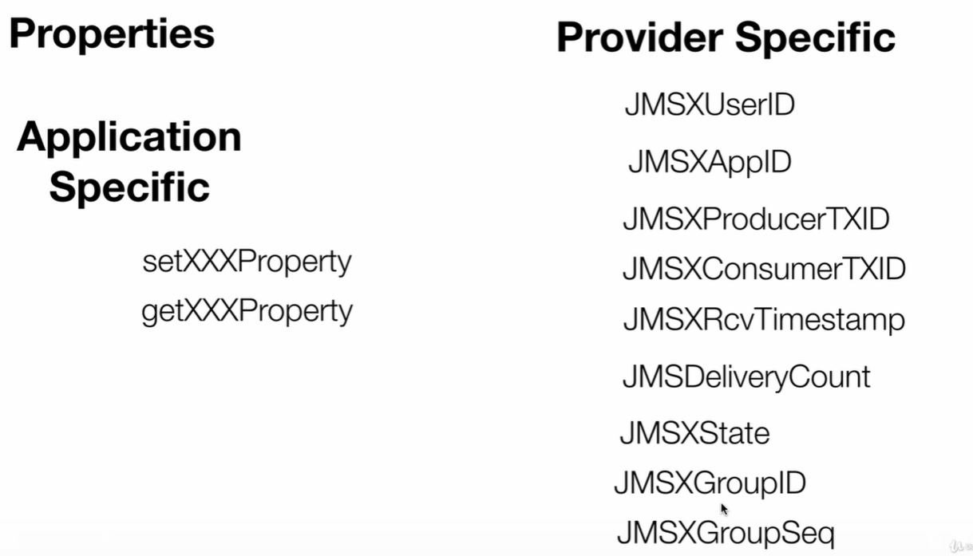

Test priority



Reply messaging



Dynamically create a reply queue



Associate a particular reply to a particular request (for multiple app requests)

Messageid and correlationid help to link a particular request to a particular reply



Set message expiration



When a message expires it is not lost completely, it will be stored in a particular place (configured automatically)





Second name is the one configured in the provider

Delay delivery



Add custom message properties



Message Types

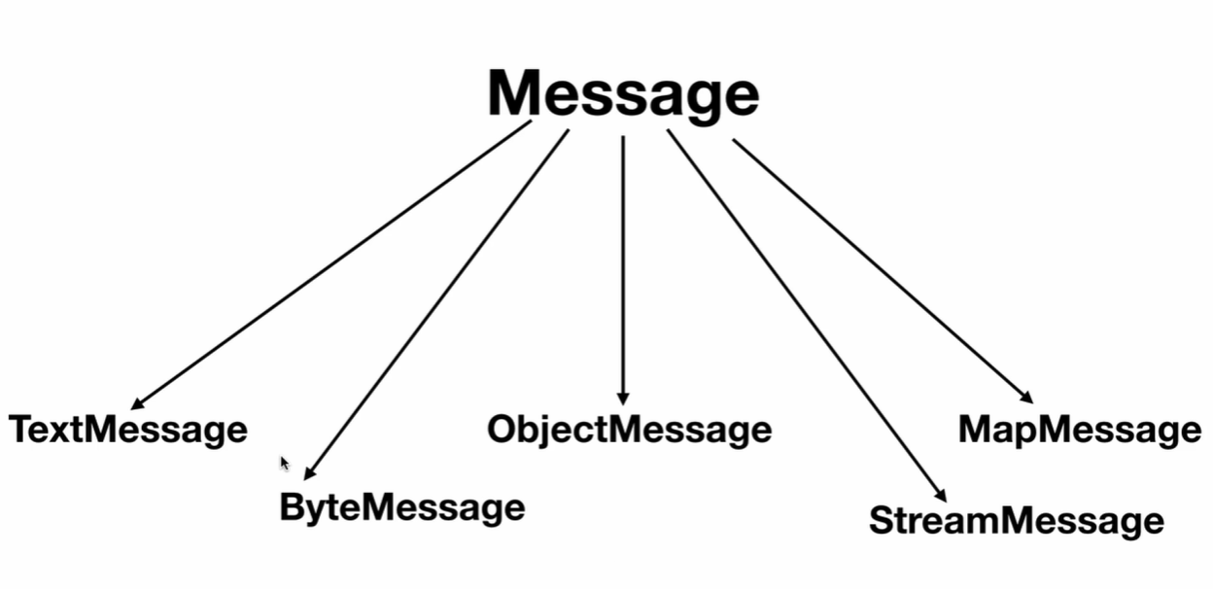

BytesMessage ex:



StreamMessage ex



Map message ex



Object Message ex:





JMS 2

Sent types easies using the overloaded method of send







Help and contact, contact us, selling, payment hold on your sold items, chat with our automated assistant

When to use P2P

One to one communication

Once the message is read is gone



Asynchronous process

The client don’t need to ask for the message, once it is one it will be advised by the listener







Complete





Publish/Subscribe Messaging, when to use

When we wanto to send the message across applications







PUBLISHER



SUBSCRIBERS





Get same message.

Durable subscription

What happen if one of the subscribers is down when the message is sent, they will lose the message (producer delivers the message on the topic and then deletes the message), for this case we have durable subscription.

We pass a unique clientId and a subscription name to each subscriber, then the jms provider will keep track of the subscribers who have received the message using this clientid and subscription name, if there Is any that hasn’t receive the message, it will retain the message until they get the message, once the subscriber is up it will deliver the message to it and the remove it from the topic.



Shared consumer (many consumers on same subscriber)



Message Filtering

Consumer want to consume the message only in a particular condition

Only work on message properties and header, not on the payload

It is added on the queue so only desired messages will reach the consumer If apply

Sender app is responsible of setting the properties and headers





Only on this headers

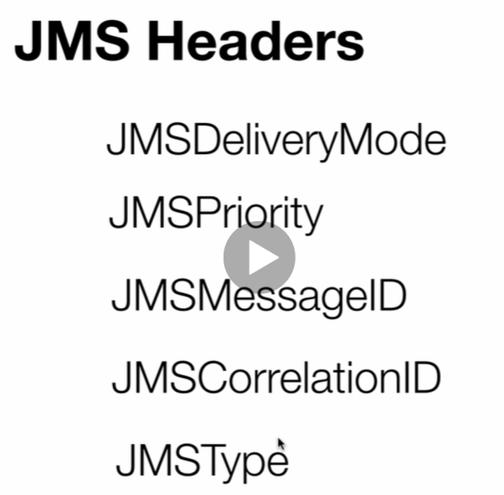









JMs guarantee messaging through message acknowledgments





It happens automatically, once it is send by the producer and received by the jms server it returns an acknowledgement and is responsible of sending that message to the consumer, the ack sent doesn’t mean it has been deliver to the consumer.



Dups OK Acknowledge explicitly has to acknowledge

It can send the message more than one to the same consumer, it can send the message any number of times until it respons it has been delivered



Client Acknowledge

Jms consumer takes the acknowledgement in its own hands (jms server not blocked) jsm consumer will acknowledge it in some point while the jms server can work on other thing



On message consumer:

You need to acknowledge it explicitly on the client, otherwise the message provider will retain the message on the queue



Transacted messages

It wont go to the jms server until a commit() has been send, if before that a rollback is send then it wont reach the jms server (they will go to a cache where it stays until a commit or a rollback is received)

On the consumer side you can receive messages but until you give a commit() they will be gone from the queue or topic, jms server will retain the messages till that, rollback here will produce the jms server to resend the messages for processing to the consumer again



Only message 1 will be delivered



Only message 1 delivered



Consumer context as transacted and send commit to make it remove from the jms server

Security

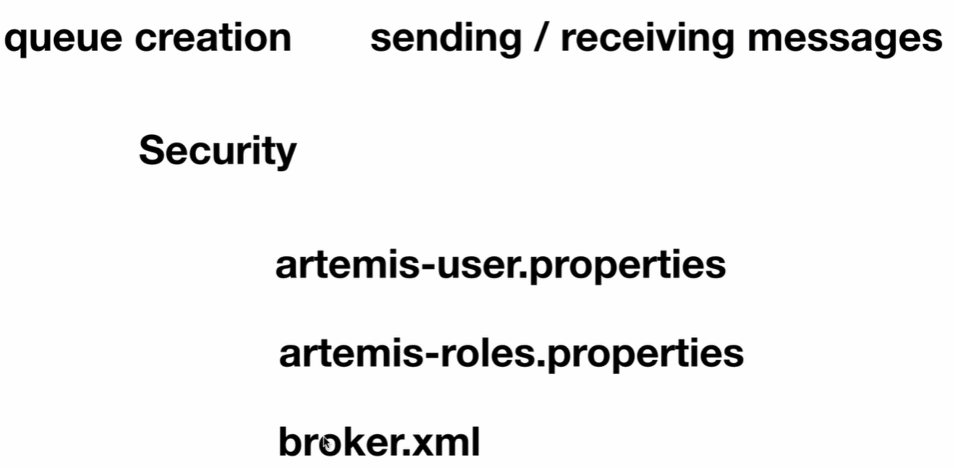



Artemis-users Users and passwords allowed to connect

Artemis-roles roles allowed

Broker.xml

Users and roles will be set in this file in the <security-settings>

Artemis-users



Artemis-roles



Broker.xml

 jndi properties

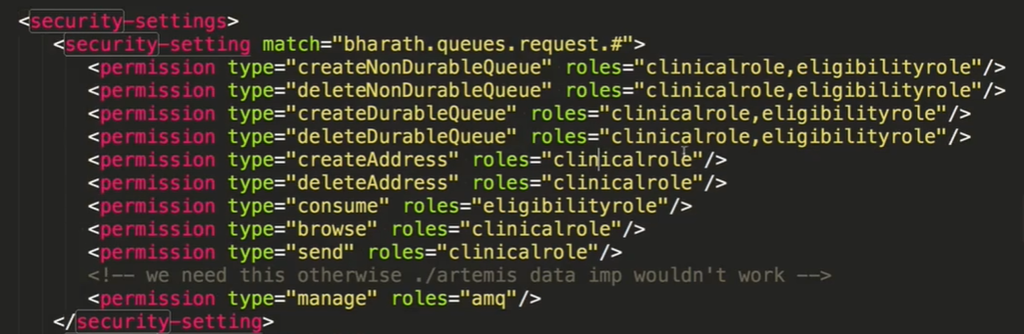





Message grouping

Send a group of messages to a single consumer

